Biology 121 Test 2 Fall 2010

DETERMINE THE BEST ANSWER FOR EACH QUESTION. PLACE YOUR ANSWER IN THE CORRESPONDING SPACE ON THE ANSWER SHEET.

- Which of the following is NOT true of proteins? MPO 1.3
  - May be denatured (lose their shape) by a change in temperature or pH.
  - Some types can be called enzymes
  - Appear to be the molecular carriers of the coded hereditary information
  - Have 1-4 levels of structure

- The overall structure (shape) of a protein is directly determined by: MPO 1.3
  - The amount of nitrogen atoms present
  - The primary amino acid sequence of the protein
  - Whether or not ribosomes are free or associated with the endoplasmic reticulum
  - The position of the peptide bonds

- Carbohydrates are stored in the liver and muscles in the form of MPO 1.3
  - Glucose
  - Triglycerides
  - Glycogen
  - Disaccharides
  - Cholesterol

- Which of the following is the major positive ion inside cells? MPO 1.5
  - Nitrogen
  - Hydrogen
  - Potassium
  - Calcium
  - Sodium

- To produce sucrose (a disaccharide) MPO 1.3
  - Two amino acids must form a peptide bond
  - Pairing of nitrogenous bases must occur between nucleotides
  - Glucose and fructose must undergo a condensation synthesis reaction
  - Glucose and fructose must undergo a hydrolysis reaction
  - At least two fatty acids must bind to glycerol

- Amino acids are joined by MPO 1.3
  - Lytic bonds
  - Ionic bonds
  - Fibrous proteins
  - Peptide bonds

- Cells try to move sodium ions from the cytoplasm to the outside of the cell, where the sodium concentration is 14 times higher than in the cytoplasm. This means sodium ions are moved out of the cell by MPO 1.4
  - Simple diffusion
  - Facilitated diffusion
  - Osmosis
  - Active transport
  - Filtration

- An organelle which varies in number in direct proportion to the energy needs of the cell is a
  - Nucleus MPO 1.5
  - Nucleolus
  - ATP
  - Mitochondrion
  - Golgi complex

- Neutral fats have a _____ ratio of fatty acids to glycerol. MPO 1.3
  - 1:1
  - 2:1
  - 3:1
  - 4:1

- DNA replication occurs in the
  - M phase of the cell cycle
  - Prophase
  - Interphase
  - Cytokinesis phase of the cell cycle
  - G phase of the cell cycle

- The RNA responsible for bringing the amino acids to the factory site for protein synthesis is the
  - rRNA MPO 1.5
  - mRNA
  - tRNA
  - ssRNA

- The plasma membrane is important for which of the following reasons MPO 1.4
  - It is selectively permeable
  - It defines the boundaries of the cell
  - It acts as a site for cell-to-cell interaction and recognition
  - All of the above are correct

- Which of the following processes/characteristics would be affected by the absence of microtubules? MPO 1.5
  - Motility
  - The arrangement of cell organelles
  - Cell division
  - All of the above would be affected

- What can you tell about the following nucleotide (nitrogenous base) sequence:
ADENINE-URACIL-GUANINE MPO 1.5
  - It could be part of DNA
  - It could be part of RNA
  - A complementary strand of RNA nucleotides would be THYMINE-ADENINE-CYTOSINE
  - The bases are linked by peptide bonds
  - Both A and C are correct

- During the process of translation, the code carried by mRNA is MPO 1.5
  - Turned into DNA
  - Decoded into a protein
  - Decoded into a pentose
  - Used to manufacture tRNA

- Simple diffusion MPO 1.4
  - Occurs from regions of higher to lower concentrations by the interaction of solute molecules with specific membrane transport systems
  - Moves a substance from an area of lower concentration to an area of higher concentration against its concentration gradient
  - Is a process involving the unaided net movement of a substance from a region of higher concentration to a region of lower concentration
  - Can only take place across a living cell membrane

- A “saturated fat” is saturated with MPO 1.3
  - Hydrogen
  - Aluminum
  - Carbon
  - Iron
  - Oxygen

- All proteins destined for export from the cell follow a similar route. Which of the following is the correct sequence of events for the protein after it is synthesized by the ribosome? MPO 1.5
  - RER → transport vesicles → secretory vesicles → Golgi complex → released via exocytosis
  - Secretory vesicles → RER → Golgi complex → transport vesicles → released via exocytosis
  - Golgi complex → secretory vesicles → transport vesicles → RER → released via exocytosis
  - RER → transport vesicles → Golgi complex → secretory vesicles → released via exocytosis
  - Transport vesicles → RER → secretory vesicles → Golgi complex → released via exocytosis

- Which of the following is NOT a type of protein filament which comprises the cytoskeleton?
  - Intermediate filaments MPO 1.5
  - Macrotubules
  - Microfilaments
  - Microtubules

- _____ is an essential component of the cell membrane but is infamous for its relationship to “hardening of the arteries”. MPO 1.4
  - Prostaglandin
  - Estrogen
  - Eicosanoid
  - Cholesterol

- Once solid material is phagocytized and taken into a vacuole, which of the following statements best describes what happens? MPO 1.5
  - A ribosome enters the vacuole and uses the amino acids from the “invader” to form new protein
  - A lysosome combines with the vacuole and digests the enclosed solid material
  - The vacuole remains separated from the cytoplasm and the solid material persists unchanged
  - Oxygen inters the vacuole and “burns” the enclosed solid material

- Denaturation of a protein always results in MPO 1.3
  - Loss of biological function
  - Addition of new amino acids to the molecule
  - Destruction of the primary structure
  - Formation of new hydrogen bonds
  - Stimulation of new protein synthesis

- Carrier molecules within the cell membrane are required in order to transport a substance across a membrane via MPO 1.4
  - Osmosis
  - Filtration
  - Facilitated diffusion
  - Simple diffusion

- Cell membrane receptors are usually what type of molecules? MPO 1.4
  - Phospholipid
  - Protein
  - Cholesterol
  - Nucleic acid

(25-28). Name the phase of mitosis during which each of the following events takes place.
- Spindle fibers begin to form.
- Chromosomes first become visible as bar-like bodies.
- Nuclear membrane and nucleolus reappear.
- Chromosomal centromeres split and chromosomes migrate to opposite ends of the cell.

- You are using a compound microscope with a total magnification of 500x. The oculars are standard magnification. What is the magnification of the objective lens?

- _____ is the change that a cell undergoes from an un-specialized one to a specialized one.
  - Differentiation
  - Metabolism
  - Movement
  - Reproduction
  - Responsiveness

(31-32). The picture below shows diffusion in an agar plate set-up.
31. Which substance moved faster?
32. Why did that substance move faster?
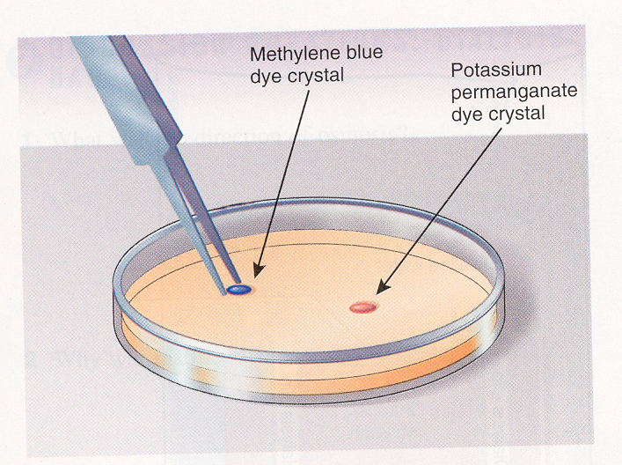

(33-38). In the figure below, identify the shape of the RBC, and the type of solution the RBC is in.
The large arrows show the net water movement.
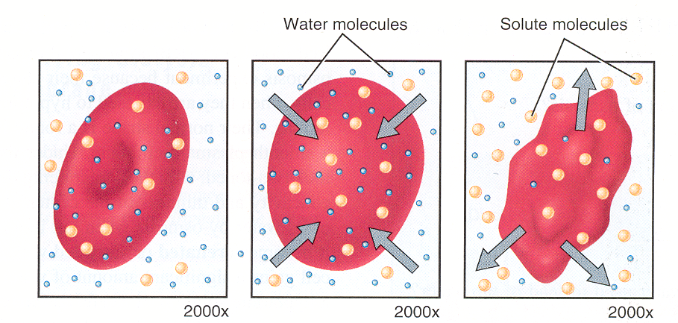

33, 34 35, 36 37, 38

MPO 1.4 MPO 1.4 MPO 1.4
(39-46). The figure below shows the molecular structure of DNA. Adenine = A, Cytosine = C.
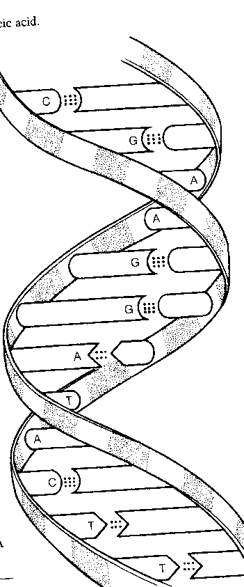
39, 40. Identify the two unnamed nitrogen bases by their
single letter abbreviations and full names.
4848
41, 42, 43, 44. Identify the numbered bases on the
diagram.

45. Name the bonds that help hold the two DNA
strands together.

46. Name the three-dimensional shape of the DNA
molecule.

MPO 1.3 (39 – 46)

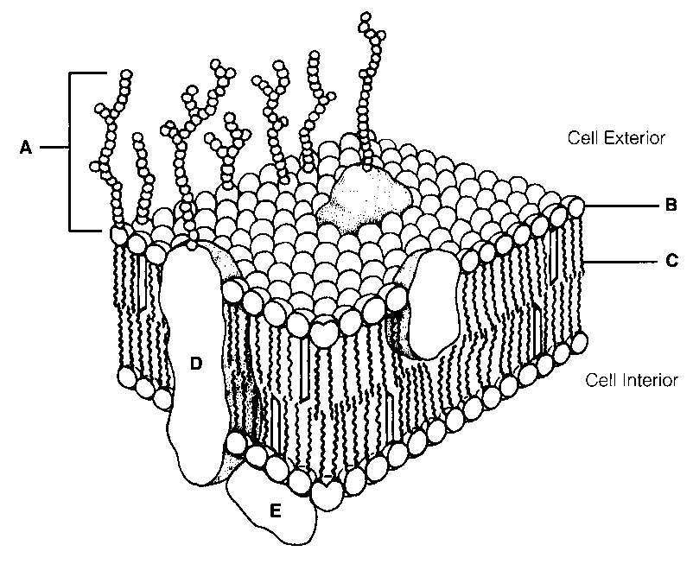
(47-48). The figure below is a portion of a plasma membrane.

47. Which label, B or C, indicates the nonpolar region
of a phospholipid molecule?

- Which label, D or E, indicates an integral
membrane protein?
MPO 1.4 (47 – 48)

- DNA could code for the synthesis of only one of the
following, namely MPO 1.5
  - testosterone
  - Glycogen
  - Collagen
  - Phospholipids
  - Fats

- Protein synthesis involves an anticodon, a base triplet, and a codon. These are parts of the _______ molecules, respectively. MPO 1.5
  - tRNA, DNA, and mRNA
  - DNA, tRNA, and mRNA
  - mRNA, rRNA, and tRNA
  - DNA, RNA, and polypeptide
  - RNA, DNA, and polypeptide
Bonus Question:

Name and describe the four phases of mitosis in sequence. (6 points)

Write your answer in the space below.

Biology 121 – Test 2

Data obtained October 12, 2010

N = 43

Question # | MPO | # Correct | Percentage | Average for same MPO
1 | 1.3 | 26 | 60
2 | 1.3 | 23 | 53
3 | 1.3 | 17 | 40
4 | 1.5 | 17 | 40
5 | 1.3 | 14 | 33
6 | 1.3 | 39 | 91 | 56.7
7 | 1.4 | 18 | 42 | 49.4
8 | 1.5 | 27 | 63 | 55.9
9 | 1.3 | 14 | 33
11 | 1.5 | 25 | 58
12 | 1.4 | 40 | 93
13 | 1.5 | 31 | 72
14 | 1.5 | 30 | 70
15 | 1.5 | 17 | 40
16 | 1.4 | 20 | 47
17 | 1.3 | 20 | 47
18 | 1.5 | 26 | 60
19 | 1.5 | 24 | 56
20 | 1.4 | 36 | 84
21 | 1.5 | 31 | 72
22 | 1.3 | 13 | 30
23 | 1.4 | 23 | 53
24 | 1.4 | 13 | 30
33 | 1.4 | 26 | 60
34 | 1.4 | 13 | 30
35 | 1.4 | 25 | 58
36 | 1.4 | 14 | 33
37 | 1.4 | 15 | 35
38 | 1.4 | 14 | 33
39 | 1.3 | 26 | 60
40 | 1.3 | 26 | 60
41 | 1.3 | 29 | 67
42 | 1.3 | 27 | 63
43 | 1.3 | 27 | 63
44 | 1.3 | 34 | 79
45 | 1.3 | 20 | 47
47 | 1.3 | 35 | 81
48 | 1.4 | 30 | 70
49 | 1.4 | 10 | 23
50 | 1.5 | 12 | 28

MPO 1.3 MPO 1.4 MPO 1.5

